Procurement Management Portal
ABC Tech.

Project Details:

Project ID:
ABC/PMP/PRJ/2025

Version:
1.0

Document No.:
ABC/PMP/PRJ/2025/1.0

Date:
01/01/2025

Author:
Frodo Baggins

Version:
Date | Version No. | Author | Reviewed By | Approved By | Description | Status
01/01/2025 | 1.0 | Frodo Baggins | PM | SME | Initial Draft | Draft

Table of Contents

Project Details: 1
Project ID: 1
Version: 1
Document No.: 1
Date: 1
Author: 1
Version: 1
Table of Contents 2
Executive Summary 4
Project Description 4
Business Context 5
1. Background Information 5
1.1. Trigger Events / Conditions Leading to Initiation / Business Drivers 5
1.2. Problem Areas 5
1.3. Current Challenges / Pain Points 5
2. Business Goals 5
3. Business Objectives 6
4. Business Value 6
Stakeholder Analysis 7
Stakeholder List, Roles & Approval Matrix 7
RACI Matrix 7
User Roles 8
Scope of Work 9
In-Scope 9
Out-of-Scope 9
Business Process 10
Current Process (AS-IS) 10
Future Process (TO-BE) 11
Business Rules 12
Requirements 13
Business Requirements 13
Functional Requirements 13
Non-Functional Requirements 15
Requirements Traceability Matrix (RTM) (if applicable) 16
Testing & Acceptance Criteria (optional) 16
Assumptions 18
Constraints 18
Limitations (Optional) 18
Risks 19
Dependencies 19
Change Control Process (Optional) 20
Training & Support Requirements (Optional) 20
Training Plan 20
Training Materials 21
Data Migration & Integration Requirements (If applicable) 21
Data Migration 21
System Integration 22
Timeline / Milestones (Optional) 22
Appendices 24
Supporting Diagrams 24
Sample Forms or Templates 24
Additional Data 24
Glossary of Terms 24

Executive Summary
The Procurement Management Portal (PMP) for ABC Tech is designed to replace the current email-driven procurement process with a digital solution that ensures seamless request handling, multi-level approvals, and vendor coordination.
This transformation will reduce turnaround time, increase visibility for all stakeholders, and establish a single source of truth for hardware procurement activities.

Project Description
Currently, hardware procurement at ABC Tech is managed through manual email communication, involving multiple layers of approval and coordination between employees, managers, purchase teams, vendors, warehouse, and accounts. This process often leads to delays, missed requests, and lack of transparency. The new portal will automate and centralize the workflow, enabling end-to-end tracking, streamlined approvals, and improved communication among all stakeholders.

Business Context

Background Information

Trigger Events / Conditions Leading to Initiation / Business Drivers
Multiple complaints by employees regarding delays in approval.
Instances of missed requests observed due to operational overload or system gaps.
Lack of tracking & status updates in many instances led to procurement / payment related inefficiencies.

Problem Areas
Many requests tent to take longer than expected to get approved leading to productivity loss and sometimes leading to missed deadlines/client escalations.
No clear status tracking available leading to lack of transparency and manual tracking efforts leading to loss in efficiency and productivity of the employees, delays in order procurements & fulfilments.

Current Challenges / Pain Points
Team Leads and Managers face increased operational overhead due to the lack of a central portal for managing requests.
Employees have no reliable way to check the status of their hardware requests, leading to frustration and repeated follow-ups.
Audit compliance is compromised due to missing or pending requests which cannot be automatically tracked.
Accounts Team and Vendors experience delays in receiving POs and payment processing, further impacting fulfilment timelines.

Business Goals
Digitally transform the procurement process to improve efficiency, compliance, transparency & user experience.
Reduce friction/delays in order placement and approval.
Make approval process streamlined and transparent.
Enable better tracking of hardware requests and fulfilments.
Enable end-to-end tracking of the orders from employee-TL-Manager-Warehouse-Vendor-Purchase-Accounts.

Business Objectives
Replace the current email-based system with the portal within 6 months.
Reduce average approval time for hardware requests by 50%
Achieve zero missed requests due to process gaps.

Business Value
The portal will digitize and automate procurement process which will reduce the manual errors and administrative overhead.
It will eliminate missed requests and improve transparency.
It will provide real-time status visibility to all stakeholders.
Improved process transparency and auditability will support compliance and faster issue resolution.
The organization will benefit from faster procurement cycles, better vendor management, and data-driven decision-making.

Stakeholder Analysis

Stakeholder List, Roles & Approval Matrix
Role | Name | Title | Signature | Date
Project Sponsor | Dr. Voldemort | Director, ABC Tech
Business Owner | Hermione Granger | Manager, IT Operations
SME | Ron Weasley | Team Lead
SME | Draco Malfoy | Team Lead
SME | Sirius Black | Head of Purchase
SME | Hagrid | Head of Warehouse
SME | McGonagall | Head of Accounts
Project Manager | Aragorn | Project Manager
Product Owner | Gandalf | Product Owner
System Architect | Bilbo | System Architect
Team Lead | Elrond | Lead
Business Analyst | Frodo Baggins | Business Analyst
Quality Lead | Legolas | QA

RACI Matrix
R | Responsible | Responsible for creating this document.
A | Accountable | Accountable for accuracy of this document
C | Consulted | Provides input.
I | Informed | Must be informed of any changes.

Activity | PM | BA | Dev | DBA | TL | Sy. Arch. | QA / Tester | Client / SME
BRD |  | RA |  |  |  |  |  | *
Coding |  |  | R |  |  | A
Database |  |  |  | RA
System Architecture |  |  |  |  |  | RA |  | C
Testing | C | C |  |  | R |  | RA | I
UAT | C | C |  |  |  |  | C | RA / *
Deployment | RA |  | R | C | R | C | I | I
Training |  | RA |  |  |  |  | C | C

User Roles
Role | Description | Key Permissions / Actions
Employee | Requests hardware | Create/view requests, track status
Lead | Approves requests ≤ Rs. 5000 | Approve/reject, escalate higher-value requests
Manager | Approves requests > Rs. 5000 | Approve/reject, oversee process
Purchaser | Manages procurement process | Issue RFQs, select vendors, create/send POs
Warehouse Team | Handles receipt and inspection of goods | Accept/reject goods, update inventory, create GRN
Accounts Team | Manages payments | Receive invoices, perform 3-way match, process payment
Vendor | Supplies goods and invoices | Respond to RFQs, deliver goods, send invoices

Scope of Work

In-Scope
Role | Portal Features / Scope | Remarks / Process Steps
Employee | Raise new hardware request  View/modify/delete own requests  Receive notifications on request status | Can track request through portal; initiates process
Lead | Approve/reject requests below Rs. 5000  View/modify/delete own requests  Raise requests  Receive notifications on approvals/rejections | Approves within authorized budget
Manager | Approve/reject requests > Rs. 5000  View/modify/delete own requests  Raise requests  Receive notifications on approvals/rejections | Handles escalated/high-value requests
Purchaser | View approved requests  Generate/send RFQs to vendors  Receive/compare quotations  Select vendor & Raise PO  send PO to vendor  Receive notifications on RFQ/PO status | Automates vendor communication and PO process
Warehouse Team | View incoming goods  Inspect/accept/reject goods  Prepare goods Receipt Note (GRN)  Receive notifications on goods Receipt | Updates inventory and triggers next steps
Accountant | View POs, GRNs, invoices  Perform 3way matching  Approve/process payments  Receive notifications on payment status | Ensures compliance and payment accuracy
All Users | Register/login/forgot password  Access role-based dashboard  Participate in training/demo sessions | General portal access features

Out-of-Scope
Vendor Management.
Interface with existing Accounting Software.
Migration & Validation of data & requests in the current system before go-live date.

Business Process

Current Process (AS-IS)
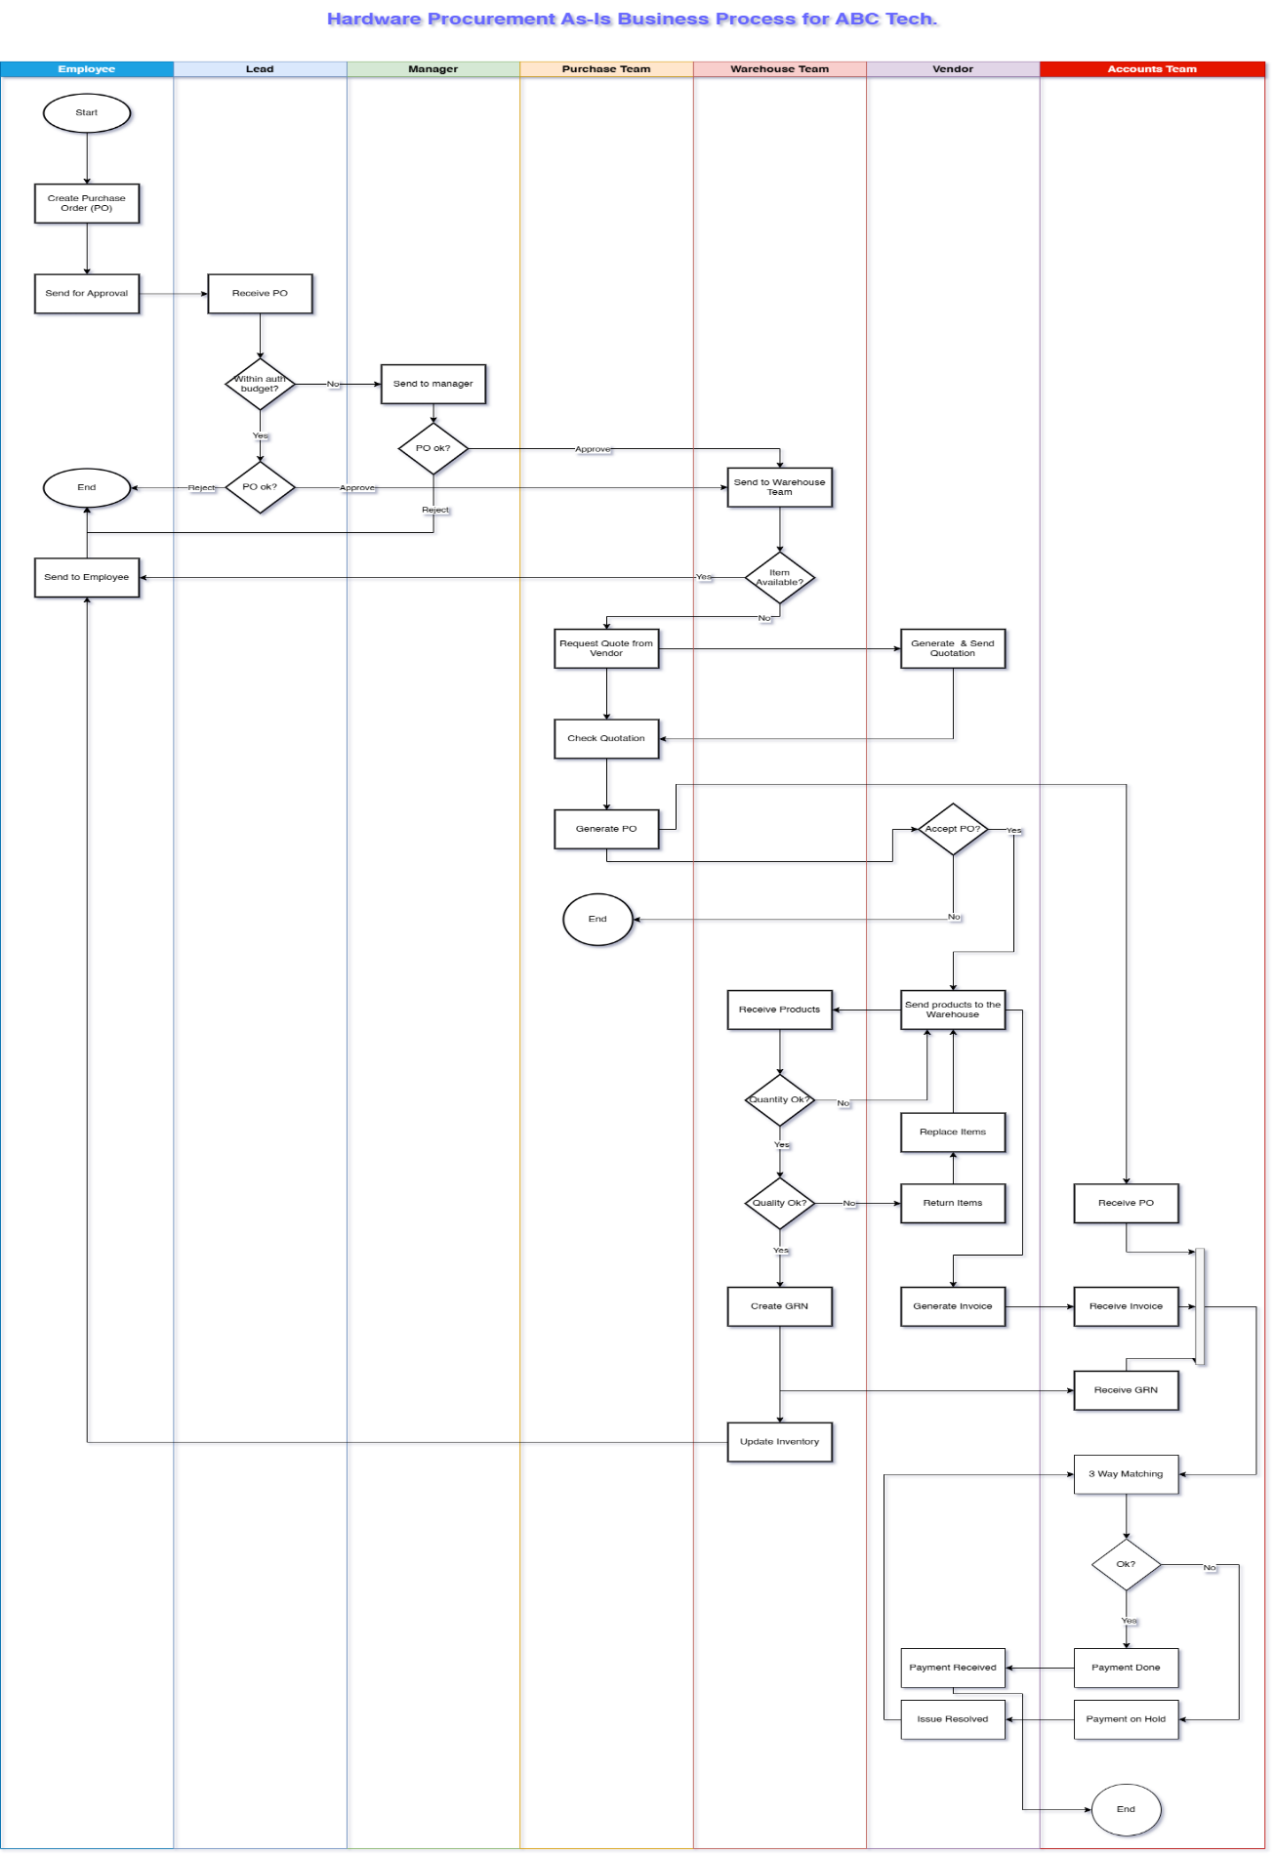

Future Process (TO-BE)
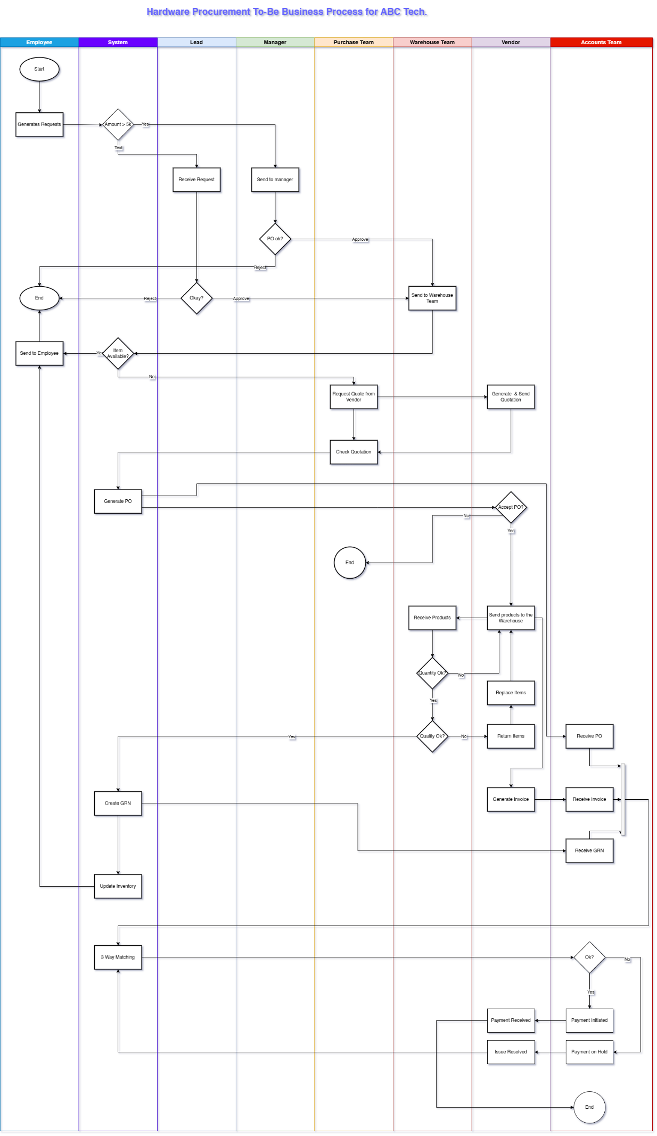

Business Rules
Rule ID | Description
BR-01 | Team Lead can approve requests up to ₹5000 only
BR-02 | Requests exceeding ₹5000 must be approved by the Manager
BR-03 | A request must be approved before being processed further
BR-04 | If inventory is available, the Warehouse must fulfil before routing to Purchase
BR-05 | A valid PO must be generated before goods can be ordered from the vendor
BR-06 | All goods received must pass quantity and quality checks before GRN is created
BR-07 | GRN, Invoice, and PO must match before payment is approved (3-way match)
BR-08 | Any rejected item must be either returned or replaced before proceeding

Requirements

Business Requirements
Requirement ID | Requirement
BR01 | Digitize & automate manual email-based hardware procurement process.
BR02 | Reduce average approval time.
BR03 | Reduce friction/delays in order placements and approvals.
BR04 | Make approval process streamlined and transparent.
BR05 | Enable end-to-end tracking & status updates of all hardware requests and fulfilments.
BR06 | Make the procurement process user friendly.
BR07 | Ensure audit & compliance needs are met.
BR08 | Provide role-based access and actions for all stakeholders .

Functional Requirements
Requirement ID | Feature | Requirement
All Employees
FR01 | Registration | Ability to register as a new user
FR02 | Login | Ability to login & log out
FR03 | Password Reset | Ability to reset password
FR04 | Dashboard | Ability to view dashboard
FR05 | Generate Requests | Ability to generate a new hardware procurement request
FR06 | View / Modify / Delete Requests | Ability View / Modify / Delete own requests
Lead & Manager
FR07 | Approval | Ability to view requests
FR08 | Approval | Ability to approve requests
Warehouse Team
FR09 | Close Request | Ability to close a request on successful completion
FR10 | Route to Purchase | Ability to rout the request to purchase team (when requested item is not available in the warehouse)
FR11 | Check Inventory | Ability to check availability of the hardware requested.
FR12 | Receive Goods
FR13 | Quantity Received | Ability to mark goods received in full or partially
FR14 | Prepare GRN | Ability to generate a Goods Received Note (GRN)
FR15 | Inspection of Goods | Ability to flag goods incorrect or damaged
FR16 | Forward GRN | Ability for route GRN to Accounts Team
Purchase Team
FR17 | Receive Request | Ability to view request forwarded by the warehouse team
FR18 | Issue RFQ | Ability to create RFQ & send it to vendors
FR19 | Quote Received | Ability to add received quotes to the system
FR20 | Create PO | Ability to create a Purchase Order & send it to the selected vendor
Accounts Team
FR21 | Receive Invoice | Receive invoice from Vendor
FR22 | Receive GRN | Receive GRN from Warehouse
FR23 | Receive PO | Receive PO from Purchase
FR24 | 3 Way Matching | Ability to compare PO, Invoice & GRN
FR25 | Payment Status Update | Ability to push payment status update like  Successful,  On-Hold,  Failed etc.

Non-Functional Requirements
Requirement ID | Feature | Requirement
NFR01 | System Uptime | System uptime of at least 99% during business hours
NFR02 | Concurrent users | Support for at least 700 concurrent users.
NFR03 | Audit Compliance | Log all transactions
NFR04 | Data Migration & Validation | Data migration from existing email-based system must be accurate and validated before go-live.
NFR05 | UI / UX | The portal should be responsive and accessible via desktop & mobile web browsers.
NFR06 | UI / UX | Portal interface should be intuitive and user-friendly, requiring minimal training for end-users.

Requirements Traceability Matrix (RTM) (if applicable)
BR ID | Business Requirement | Functional Req. | Non-Functional Req. | User Stories | Status
BR01 | Digitize & automate manual email-based hardware procurement process | FR01–FR06, FR17–FR20 | NFR01, NFR04, NFR05 | TBD | Draft
BR02 | Reduce average approval time | FR07, FR08 | NFR01 | TBD | Draft
BR03 | Reduce friction/delays in order placement and approval | FR05–FR08, FR10, FR17 | NFR01, NFR02 | TBD | Draft
BR04 | Make approval process streamlined and transparent | FR04, FR07, FR08 | NFR01, NFR03 | TBD | Draft
BR05 | Enable end-to-end tracking & status updates | FR04, FR09, FR10, FR13, FR14, FR16, FR23 | NFR01, NFR03 | TBD | Draft
BR06 | Make the procurement process user-friendly | FR01–FR06 | NFR05, NFR06 | TBD | Draft
BR07 | Ensure audit & compliance needs are met | FR04, FR13, FR14, FR24 | NFR03 | TBD | Draft
BR08 | Provide role-based access and actions for all stakeholders | All FRs grouped by role | NFR02, NFR05 | TBD | Draft

Testing & Acceptance Criteria (optional)
Few sample ACs for example!
FR ID | Description | Acceptance Criteria
FR-02 | Submit hardware request | All fields are mandatory  Request ID is autogenerated  Confirmation message appears
FR-04 | Cost-based routing | ≤ ₹5000 → Lead  > ₹5000 → Manager  Notification sent to approver
FR-06 | Warehouse checks inventory | Inventory quantity auto-displayed  “Item Not Available” routes to Purchase
FR-10 | 3-Way Match | GRN, PO, Invoice must exist and match before marking “Ready for Payment”
FR-11 | Request Tracking | Status is visible at every stage to the employee  Final status is “Fulfilled” or “Rejected”

Assumptions
All stakeholders will cooperate and provide timely data & approvals when necessary.
There will be no major changes in procurement policy during the project
All employees will access the system through a modern web browser.
All users have basic digital literacy and can use a web portal.
The approval hierarchy (Lead vs. Manager) is pre-defined and accurate.
Pending requests will be migrated by respective departments before go-live.
Necessary stakeholders (Leads, Warehouse, Accounts) will be available for UAT.

Constraints
Constraint ID | Description | Source
C-01 | Must be delivered in 6 months | Project Timeline
C-02 | Web portal only (no mobile app) | IT Policy
C-03 | Only hardware items in scope | Business Agreement
C-04 | No system integration in Phase 1 | Technical Limitation
C-05 | No additional hardware or cloud infrastructure budget allowed | Budget

Limitations (Optional)
Limited availability of several key SMEs/Stakeholders is anticipated based on their current workloads.
Some manual processes may persist during transition.
Automated analytics dashboards or KPI reporting are not included in this phase.
Several key SMEs (e.g., from Purchase and Accounts) have limited availability for continuous feedback.
The system will not support mobile access in this release; portal access will be available only through desktop browsers.

Risks
Risk ID | Description | Impact | Likelihood | Mitigation / Response
R-01 | Delay in requirement reviews and sign-offs from SMEs | High | High | Pre-schedule review sessions; escalate delays via PM; involve backups
R-02 | Resistance to adoption of the new portal from end users | High | Medium | Conduct early training, live demos, and nominate “change champions” from each department
R-03 | Incomplete or inaccurate migration of pending hardware requests to the new system | Medium | High | Assign each department responsibility for verifying and cleaning its request backlog before go-live
R-04 | Unplanned changes in the approval hierarchy or escalation matrix during the project | Medium | Low | Freeze approval workflow design before development; allow post-go-live configuration changes only
R-05 | Delay in user training completion before go-live | High | Medium | Schedule training at least 2 weeks before rollout; track attendance and engagement
R-06 | Limited availability of key stakeholders due to workload or other projects | Medium | Medium | Get stakeholder commitment documented early; use status reports and reminders to maintain engagement
R-07 | Browser or technical compatibility issues during rollout | Low | Medium | Restrict supported browsers to latest Chrome/Edge/Firefox; test thoroughly across OS and screen sizes

Dependencies
Depen-dency ID | Description | Owner / Team | Required By | Risk If Not Met
D-01 | Clean vendor master data and item catalogue | Purchase Team | Before UAT | RFQ/PO generation will be blocked
D-02 | Inventory stock details loaded into system | Warehouse Team | Before UAT | Test cases will fail; partial process simulation only
D-03 | Pending requests migrated from email system | Department Admins | Before go-live | Go-live won’t reflect real-state demand
D-04 | Training calendar and trainers confirmed | Training Coordinator / IT | 2 weeks before go-live | Users may reject or misuse portal
D-05 | Stakeholder availability for UAT | All SME Departments | During UAT window | UAT delays and insufficient feedback
D-06 | Hosting & server configuration | IT Infrastructure Team | Before system deployment | Cannot deploy/test portal environment

Change Control Process (Optional)
Sample data
Change ID | Description | Submitted By | Impact Summary | Status | Approved By | Date
CR-01 | Add dropdown for “Urgency Level” in request form | IT Ops | UI change; dev time: 2 hours; no DB impact | Approved | PM, PO | 04-Jul-2025
CR-02 | Include “Software procurement” in scope | Business | High impact; expands scope; delays by 2 weeks | Rejected | Sponsor | 08-Jul-2025

Training & Support Requirements (Optional)

Training Plan
Target Users:
Employees, Team Leads, Managers, Warehouse Team, Purchase Department, and Accounts Team.
Mode of Delivery:
- Live virtual demos
- In-person walkthroughs (as needed)
- Step-by-step user manuals and quick reference guides (QRGs)

Schedule:
Training sessions will be conducted at least 1–2 weeks prior to go-live. Department-specific training calendars will be shared and coordinated via internal communication.
Training Topics (Role-Based):
- How to raise and track hardware requests (Employees)
- Approval workflows and limits (Leads & Managers)
- Inventory checks, GRN preparation (Warehouse)
- RFQ & PO generation process (Purchase)
- Invoicing, 3-way matching, and marking payment status (Accounts)
Language & Format:
All training content will be provided in English, with annotated screenshots and examples based on real-world scenarios.
Trainers:
Internal IT team, BA, and SME representatives from each department.

Training Materials
The following materials will be created and distributed:
Material | Format | Description
User Manuals | PDF | Step-by-step instructions for each role
Quick Reference Guides (QRGs) | 1-pager PDFs | Role-based visual cheat sheets
FAQs | PDF or Portal page | Common queries, troubleshooting tips
All resources will be hosted on the company’s internal knowledge portal for easy access.

Data Migration & Integration Requirements (If applicable)

Data Migration
Current State:
The existing hardware request data is stored in email threads, spreadsheets, and manual logs across various departments (IT, Warehouse, Purchase, Accounts).
Scope of Migration:
Only open or pending requests at the time of go-live will be migrated to the new portal.
Closed or fulfilled requests (historical data) not in scope.
Migration Responsibility:
Each department (Team Leads, Warehouse, Purchase, Accounts) will be responsible for validating and uploading its relevant data using a standard template provided by the BA/IT team.
Data Elements to Be Migrated:
Data Type | Fields
Hardware Requests | Requestor Generated By, Item(s) Requested, Quantity Requested, Request Date, Justification
Approval Info | Approver (Lead/Manager), Approval Status, Comments
Inventory Info | Item Code, Quantity Available
PO/Invoice Info | Vendor Name, PO Number, Invoice Number (if applicable), Amount

Validation Requirements:
- All records must be validated and cleaned before upload.
- Incomplete requests to be flagged and excluded.

System Integration
Overview
The Procurement Management Portal (PMP) will require integration with ABC Tech’s existing systems to enable seamless data flow, reduce manual effort, and improve operational efficiency. The primary integration will be with TallyPrime, which is currently used by the Warehouse, Purchase, and Accounts teams.

Scope:
- The Procurement Management Portal (PMP) must integrate with the organization's existing ERP software (TallyPrime) to enable real-time or near-real-time syncing of procurement data such as POs, GRNs, invoices, and payment status.
- All integration points must be robust, auditable, and handle exceptions gracefully.
- Any delays or failures in syncing should trigger appropriate system alerts and notifications to relevant stakeholders.”

Integration Touchpoints
Process Step | PMP Action | Tally Integration Action
PO Generation | PO created and approved | Push PO data to Tally (via API/export)
GRN Submission | GRN submitted after goods receipt | Sync GRN and stock update in Tally
Invoice Receipt | Invoice uploaded by Vendor | Record invoice details in Tally
3-Way Matching | Match PO, GRN & Invoice | Verified data pushed to Tally for audit
Payment Status Update | Mark payment as “Completed” in PMP | Update vendor ledger/payment status in Tally

Appendices

Supporting Diagrams
Diagram Name | Description | File Name
AS-IS Process Flow | Current manual procurement process (email-based) | TBD
TO-BE Process Flow (Swimlane) | Future digital process across stakeholder swimlanes | TBD
UML Use Case Diagram | Actors interacting with key system features | TBD

Sample Forms or Templates
Document Type | Purpose | File Name
Hardware Request Form | Employee hardware requisition sample | TBD
Data Migration Template | Standard format for pending request upload | TBD
Risk Register | Lists project risks and mitigation strategies | N/A
Change Request Form | Used to submit change requests post-sign-off | TBD

Additional Data
Not Applicable.

Glossary of Terms
Term / Acronym | Full Form / Meaning
PMP | Procurement Management Portal – the proposed system to manage hardware procurement
BRD | Business Requirements Document – this document outlining business needs and expectations
FRD | Functional Requirements Document – detailed breakdown of features and system behaviour
SRS | Software Requirements Specification – system-level technical specification (if applicable)
RFQ | Request for Quotation – document sent to vendors requesting a price quote
PO | Purchase Order – document confirming order of goods from vendor
GRN | Goods Received Note – record created upon receiving and inspecting delivered items
UAT | User Acceptance Testing – final validation by end users before go-live
3-Way Match | Process of matching PO, GRN, and Invoice before approving payment
SME | Subject Matter Expert – domain expert responsible for inputs/validation
BA | Business Analyst – responsible for requirements gathering and documentation
IT | Information Technology – the department responsible for system infrastructure and support
Hypercare | A short-term post-go-live support phase with heightened monitoring and assistance
MVP | Minimum Viable Product – the smallest usable version of a product delivered in Phase 1
QRG | Quick Reference Guide – short 1-pager training material or job aid
BPMN | Business Process Model and Notation – standard visual language for modelling workflows
AS-IS Process | The current/manual business process before implementing the new system
TO-BE Process | The redesigned, future process enabled by the new system
AC | Acceptance Criteria – the conditions a feature must meet to be accepted as complete
CR | Change Request – a formal request to change scope, requirements, or deliverables

